**Electrical grid**

**From Wikipedia, the free encyclopedia**

*"Power Grid" redirects here. For the board game, see Power Grid (board game).*

*For other uses, see Grid (disambiguation).*

[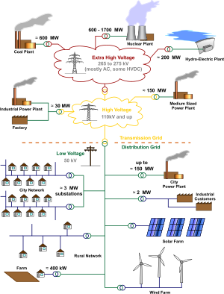](http://en.wikipedia.org/wiki/File:Electricity_Grid_Schematic_English.svg)

General layout of electricity networks. Voltages and depictions of electrical lines are typical for Germany and other European systems.

An **electrical grid** is an interconnected network for delivering electricity from suppliers

**Overview**

When referring to the power industry, "grid" is a term used for an electricity network which may support all or some of the following three distinct operations:

1. Electricity generation
2. Electric power transmission
3. Electricity distribution

The sense of grid is as a network, and should not be taken to imply a particular physical layout, or breadth. "Grid" may be used to refer to an entire continent's electrical network, a regional transmission network or may be used to describe a subnetwork such as a local utility's transmission grid or distribution grid.

Electricity in a remote location might be provided by a simple distribution grid linking a central generator to homes. The traditional paradigm for moving electricity around in developed countries is more complex. Generating plants are usually located near a source of water, and away from heavily populated areas. They are usually quite large in order to take advantage of the Economies of scale. The electric power which is generated is stepped up to a higher voltage—at which it connects to the transmission network.

The transmission network will move (wheel) the power long distances—often across state lines, and sometimes across international boundaries—until it reaches its wholesale customer (usually the company that owns the local distribution network). Upon arrival at the substation, the power will be stepped down in voltage—from a transmission level voltage to a distribution level voltage. As it exits the substation, it enters the distribution wiring. Finally, upon arrival at the service location, the power is stepped down again from the distribution voltage to the required service voltage(s).

This traditional centralized model along with its distinctions are breaking down with the introduction of new technologies. For example, the characteristics of power generation can in some new grids be entirely opposite of those listed above. Generation can occur at low levels in dispersed locations, in highly populated areas, and not outside the distribution grids. Such characteristics could be attractive for some locales, and can be implemented if the grid uses a combination of new design options such as net metering, electric cars as a temporary energy source, or distributed generation.

**Features**

**Structure of distribution grids**

The structure, or "topology" of a grid can vary considerably. The physical layout is often forced by what land is available and its geology. The logical topology can vary depending on the constraints of budget, requirements for system reliability, and the load and generation characteristics.

[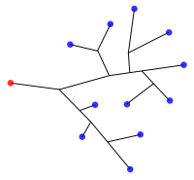](http://en.wikipedia.org/wiki/File:Grid-tree.svg)

Classic North American electricity distribution grids were simple "radial" trees, sending power from a source (red dot representing power generation or a substation) to delivery points (blue dots representing homes, businesses, or other subnetworks).

The cheapest and simplest topology for a distribution or transmission grid is a *radial* structure. This is a *tree* shape where power from a large supply radiates out into progressively lower voltage lines until the destination homes and businesses are reached.

Most transmission grids require the reliability that more complex *mesh networks* provide. If one were to imagine running redundant lines between each limb and branch of a tree that could be turned in case any particular limb of the tree were severed, then this image approximates how a mesh system operates. The expense of mesh topologies restrict their application to transmission and medium voltage distribution grids. Redundancy allows line failures to occur and power is simply rerouted while workmen repair the damaged and deactivated line.

Other topologies used are *looped* systems found in Europe and *tied ring* networks.

In cities and towns of North America, the grid tends to follow the classic "radially fed" design. A substation receives its power from the transmission network, the power is stepped down with a transformer and sent to a bus from which feeders fan out in all directions across the countryside. These feeders carry three-phase power, and tend to follow the major streets near the substation. As the distance from the substation grows, the fanout continues as smaller laterals spread out to cover areas missed by the feeders. This tree-like structure grows outward from the substation, but for reliability reasons, usually contains at least one unused backup connection to a nearby substation. This connection can be enabled in case of an emergency, so that a portion of a substation's service territory can be alternatively fed by another substation.

[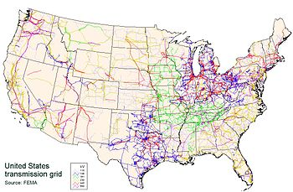](http://en.wikipedia.org/wiki/File:UnitedStatesPowerGrid.jpg)

**Geography of transmission networks**

The Continental U.S. power transmission grid consists of about 300,000 km of lines operated by approximately 500 companies.

Transmission networks are more complex with redundant pathways. For example, see the map of the United States' (right) high-voltage transmission network.

A wide area synchronous grid or "interconnection" is a group of distribution areas all operating with alternating current (AC) frequencies synchronized (so that peaks occur at the same time). This allows transmission of AC power throughout the area, connecting a large number of electricity generators and consumers and potentially enabling more efficient electricity markets and redundant generation. Interconnection maps are shown of North America (right) and Europe (below left).

Electricity generation and consumption must be balanced across the entire grid, because energy is consumed almost immediately after it is produced. A large failure in one part of the grid - unless quickly compensated for - can cause current to re-route itself to flow from the remaining generators to consumers over transmission lines of insufficient capacity, causing further failures. One downside to a widely connected grid is thus the possibility of cascading failure and widespread power outage. A central authority is usually designated to facilitate communication and develop protocols to maintain a stable grid. For example, the North American Electric Reliability Corporation gained binding powers in the United States in 2006, and has advisory powers in the applicable parts of Canada and Mexico. The U.S. government has also designated National Interest Electric Transmission Corridors, where it believes transmission bottlenecks have developed.

Some areas, for example rural communities in Alaska, do not operate on a large grid, relying instead on local diesel generators.

High-voltage direct current lines or variable frequency transformers can be used to connect two alternating current interconnection networks which are not synchronized with each other. This provides the benefit of interconnection without the need to synchronize an even wider area. For example, compare the wide area synchronous grid map of Europe (below left) with the map of HVDC lines (below right).

[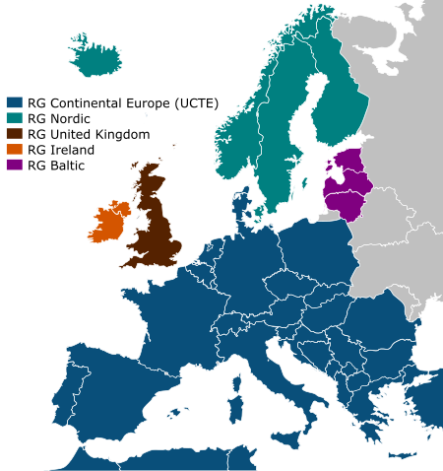](http://en.wikipedia.org/wiki/File:ElectricityUCTE.svg)

The wide area synchronous grids of Europe. Most are members of the European Transmission System Operators association.

[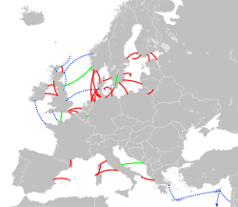](http://en.wikipedia.org/wiki/File:HVDC_Europe.svg)

High-voltage direct current interconnections in western Europe - red are existing links, green are under construction, and blue are proposed. Many of these transfer power from renewable sources such as hydro and wind. For names, see also the annotated version.

**Redundancy and defining "grid"**

A town is only said to have achieved grid connection when it is connected to several redundant sources, generally involving long-distance transmission.

This redundancy is limited. Existing national or regional grids simply provide the interconnection of facilities to utilize whatever redundancy is available. The exact stage of development at which the supply structure becomes a *grid* is arbitrary. Similarly, the term *national grid* is something of an anachronism in many parts of the world, as transmission cables now frequently cross national boundaries. The terms *distribution grid* for local connections and *transmission grid* for long-distance transmissions are therefore preferred, but *national grid* is often still used for the overall structure...

**Distributed generation**

Utilities are under pressure to evolve their classic topologies to accommodate distributed generation. As generation becomes more common from rooftop solar and wind generators, the differences between distribution and transmission grids will continue to blur.

**Modern trends**

**Deregulation**

The three components of a complete grid: generation, transmission, and distribution of electrical power, can all be found in most large utilities. A utility can be completely self-sufficient, but finds it advantageous to have the opportunity to buy and sell power to and from neighboring utilities. This improves their reliability, and that of their neighbors. Utilities are often awarded a "monopoly" status (at least at the distribution level) simply because it doesn't make sense to have competing utilities installing their hardware in the same location as another utility. The idea of a monopoly becomes less compelling as one considers the generation of electrical power. Wildly varying costs for the production of electricity, and the opportunity to encourage free market competition spurs many legislatures to move towards deregulation of the electric utilities (also known as "liberalization" in some parts of the world.) The idea of de-regulation usually involves the separation of the generation, transmission, and distribution operations into separate financial entities. Generation assets in particular can often be sold-off in piecemeal fashion to the highest bidders. With the aging infrastructure present at many utilities, and the pressure to de-regulate, there are numerous opportunities to re-engineer the system.

Transitioning utilities from regulated monopolies to a deregulated market has run into a number of challenges such as those surfaced by the California electricity crisis.

**Demand response**

Main article: Demand response

Demand response is a grid management technique where retail or wholesale customers are requested either electronically or manually to reduce their load. Currently, transmission grid operators use demand response to request load reduction from major energy users such as industrial plants.

**Distributed generation**

Main article: Distributed generation

With everything interconnected, and open competition occurring in a free market economy, it starts to make sense to allow and even encourage distributed generation (DG). Smaller generators, usually not owned by the utility, can be brought on-line to help supply the need for power. The smaller generation facility might be a home-owner with excess power from their solar panel or wind turbine. It might be a small office with a diesel generator. These resources can be brought on-line either at the utility's behest, or by owner of the generation in an effort to sell electricity. Many small generators are allowed to sell electricity back to the grid for the same price they would pay to buy it.

**Smart grid**

Main article: Smart grid

Numerous efforts are underway to develop a "smart grid". In the U.S., the Energy Policy Act of 2005 and Title XIII of the Energy Independence and Security Act of 2007. are providing funding to encourage smart grid development. The hope is to enable utilities to better predict their needs, and in some cases involve consumers in some form of time-of-use based tariff. Funds have also been allocated to develop more robust energy control technologies.

**Micro grid**

Main article: Microgrid

Decentralization of the power transmission distribution system is vital to the success and reliability of this system. Currently the system is reliant upon relatively few generation stations. This makes current systems susceptible to impact from failures not within said area. Micro grids would have local power generation, and allow smaller grid areas to be separated from the rest of the grid if a failure were to occur. Furthermore, micro grid systems could help power each other if needed. Generation within a micro grid could be a downsized industrial generator or several smaller systems such as photo-voltaic systems, or wind generation. When combined with Smart Grid technology, electricity could be better controlled and distributed, and more efficient.

**Super grid**

Main article: Super grid

Various planned and proposed systems to dramatically increase transmission capacity are known as super, or mega grids. The promised benefits include enabling the renewable energy industry to sell electricity to distant markets, the ability to increase usage of intermittent energy sources by balancing them across vast geological regions, and the removal of congestion that prevents electricity markets from flourishing. Local opposition to siting new lines and the significant cost of these projects are major obstacles to super grids.